Worksheet - 5

**Student Name:** ANIKET KUMAR **UID:**20BCS5306

**Branch:** BE-CSE **Semester:** 5th

**Subject Name:** Competitive Coding **Section/Group:** 20BCS_WM-703/B

# Task-1: Journey-to-the-moon

<https://www.hackerrank.com/challenges/journey-to-the-moon/problem?isFullScreen=true>

**Code:**

#include <cstdio>

#include <vector>

#include <queue>

#include <algorithm>

using namespace std;

bool visited[100001] = {0};

struct node {

vector<long long> neighbour;

};

long long bfs(long long, node *);

int main() {

long long n,m;

scanf("%lld %lld", &n, &m);

node nodelist[n];

long long a,b;

while(m--) {

scanf("%lld %lld", &a, &b);

nodelist[a].neighbour.push_back(b);

nodelist[b].neighbour.push_back(a);

}

long long connected = 0;

long long total = 0;

long long temp = 0;

std::vector<int> count;

for (long long i = 0; i < n; ++i) {

if(!visited[i]) {

temp = bfs(i, nodelist);

count.push_back( temp );

total += temp;

connected++;

}

}

long long answer = (total * (total - 1)) / 2;

for (int i = 0; i < connected; ++i) {

answer -= (count[i] * (count[i] - 1)) / 2;

}

printf("%lld", answer);

}

long long bfs(long long nod, node *nodelist) {

int count = 0;

queue<long long> Q;

Q.push(nod);

long long n;

while(!Q.empty()) {

n = Q.front();

Q.pop();

if(visited[n]) {

continue;

}

visited[n] = true;

count++;

for (vector<long long>::iterator itr = nodelist[n].neighbour.begin(); itr != nodelist[n].neighbour.end(); ++itr) {

if(!visited[*itr]) {

Q.push(*itr);

}

}

}

return count;

}

**Hacker Rank Test Case / Output:**

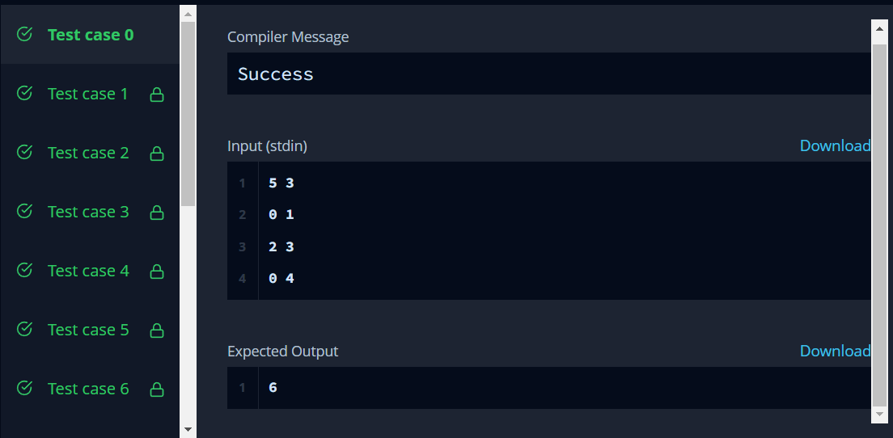

# Task-2: Frog-in-maze

<https://www.hackerrank.com/challenges/frog-in-maze/problem?isFullScreen=true>

# Code:

#include<cstdio>

char M[25][25];

int T[25][25][2];

double P[2][25][25];

const int D[4][2] = {{-1,0}, {1, 0}, {0,-1}, {0,1}};

int h,w,t;

void calc(int in, int out) {

for(int x=0;x<w;x++)

for(int y=0;y<h;y++) {

if(M[y][x] == '*' || M[y][x] == '#')

P[out][y][x] = 0.0;

if(M[y][x] == '%')

P[out][y][x] = 1.0;

if(M[y][x] == 'O' || M[y][x] == 'A') {

int count = 0; double suma = 0.0;

int px=x, py=y;

if(T[y][x][0] != -1) {px = T[y][x][0]; py = T[y][x][1];}

for(int i=0;i<4;i++) {

int x2 = px+D[i][0], y2 = py + D[i][1];

if(x2 < 0 || x2 >= w || y2 < 0 || y2 >= h)continue;

if(M[y2][x2] == '#')continue;

suma += P[in][y2][x2];

count++;

}

if(count == 0)

P[out][y][x] = 0.0;

else P[out][y][x] = suma / count;

}

}

}

double get_ans(int p) {

for(int i=0;i<h;i++)

for(int j=0;j<w;j++)

if(M[i][j] == 'A')

return P[p%2][i][j];

return -1.0;

}

int main() {

scanf("%d%d%d", &h, &w, &t);

for(int i=0;i<h;i++)

scanf("%s", M[i]);

for(int i=0;i<h;i++)

for(int j=0;j<w;j++)

T[i][j][0] = T[i][j][1] = -1;

for(int i=0;i<t;i++){

int x0, y0, x1, y1;

scanf("%d%d%d%d", &y0, &x0, &y1, &x1);

x0--;y0--;x1--;y1--;

T[y0][x0][0] = x1;

T[y0][x0][1] = y1;

T[y1][x1][0] = x0;

T[y1][x1][1] = y0;

}

const int limit = 80000;

for(int i=0;i<limit;i++) {

calc(i%2, (i+1)%2);

}

printf("%lf\n", get_ans(limit));

}

**Hacker Rank Test Case / Output:**

